Underwent java , .net , rearc training for 6 months worked on real time projects at Avasoft

Underwent java training for 6 months at Lixo technologies Pvt Ltd

Underwent internship at Piling and Pile cap works-BHEL, Ennore (Chennai) and Kanchi Yard(Kanchipuram), L & T GeoStructure

Underwent intership at residential building construction G+2, Shree Aishwaryam construction

Undergoing internship at residential apartment (G+3), Madhura Builders

Underwent intership at residential building construction G+2, Shree Aishwaryam construction

Undergoing internship at residential apartment (G+3),Madhura Builders

INTERNSHIP

Created a restaurant application using spring boot with Mongo DB

Mini project on Copper Slag Block

Paper presentation on ‘Ways to Dispose Fly Ash for NTPC limited’

Model making and paper presentation on ‘Transparent solar panel

Design project of a Multipurpose recreational building (G+2)

PROJECTS UNDERTAKEN

First prize in ‘Pipe replacement Strategy’ conducted by L&T

Third prize for model making in ACE tech fest 18’ –National Level Technical Symposium

Presented and Won 3rd place in ‘Society of Automotive Engineers’ – Topic: Transparent solar panel

* ACHIEVEMENTS



EDUCATION

Bachelor of Engineering

August 2017- August 2021

Eawari Engineering College

Senior Secondary

April 2015 - April 2017

S.D.A.V Higher Secondary School

High School

March 2002 - March 2015

D.A.V School

INTERESTS

1. Analytical Thinking

2. Critical Thinking

3.Attention to Detail

4.Time Management

PERSONAL SKILLS

CAREER

Seeking a challenging position where I can invest all my skills learn more and help for the growth of the company to achieve its goal.

Java

SKILLS

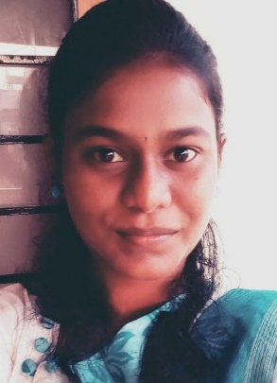

M.KRISHA

MICROSERVICE DEVELOPER

No:5, Sivaprakash nagar ,2nd street, Madipakkam, Chennai-600 091

krishamathavan@gmail.com

CONTACT

3DX Max

+91 7358188465

AutoCAD

STADDpro

1. Ability to work by myself without the need for constant supervision by employees.

2. Ability to work harmoniously with other members of the team.

3. Possess great analytical and problem solving skills.

4. Good Communication and presentation skills

INTEREST